**Ultrasonic Distance-measuring Module**

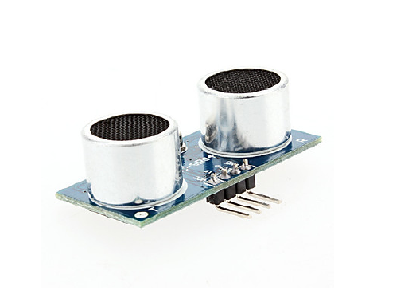

**1. Application prospect**

Ultrasonic has good directivity, low energy consumption and farther transmission distance in the medium, making it ideal for distance measurement. For example, distance meter and object position gauge use ultrasonic to realize their function. Using ultrasonic for detection is quick, convenient, simple in calculation and easy to do real-time control. Also, in terms of measurement accuracy, it can meet the requirements of industrial use. Therefore, it is widely applied in mobile robot development.

**2. Introduction**

Ultrasonic distance measuring module can provide 2cm-450cm non-touchable sensing distance, the accuracy of which reaches 3mm, sufficiently meeting our need. This module includes the ultrasonic transmitter, receiver and relevant control circuit.

**3. Working principle**

First, let’s take a look at its working procession:

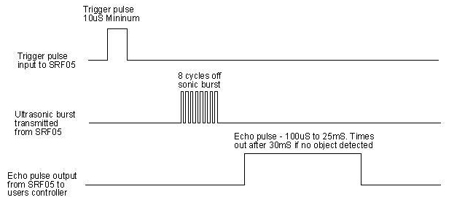

1. We first pull down TRIG, then trigger it with at least 10us high level signal;

2. After triggering it, the module will transmit eight 40KHZ square waves and automatically detect if any signal returns.

1. If there is return signal, it output a high level by ECHO. The duration of the high level is the signal transmission to receiving time. So the measuring distance equals the duration of the high level *340m/s*0.5

**4. Electrical parameter**

Working Voltage：0.5V(DC)

Working Current：15mA

Measuring Distance：2-450cm

Measuring Angle：15 degree

Input Triggering Pulse：TTL level of 10us

Output return signal：Output TTL high level signal, proportional to transmitting range

**5. Instruction**

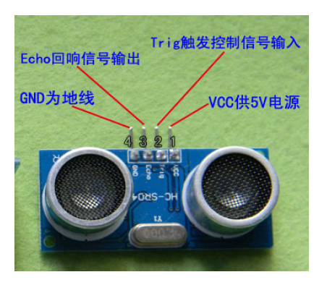

Pin specification as above pic shows. If you use an Arduino, you only need to control port Trig and Echo. Connect them respectively to two digital ports, then connect power and GND. Below is a sample program.

1. **Module Testing**

Here comes to the most interesting part-module testing.

6.1 Hardware required:

Arduino microcontroller× 1

USB cable × 1

Ultrasonic module × 1

6.2 Connection

Below is the circuit connection

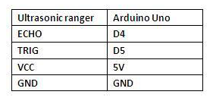

D4, D5 refer to digital ports 4 and 5; you can see the connection photo below.

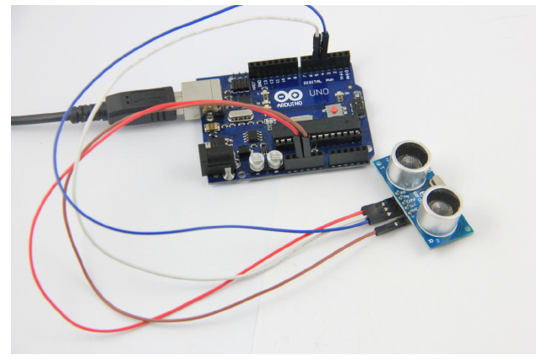

Well, this time, we will learn how to use it for measuring distance and display the result on the computer screen. If you want it to look better, you can add an LCD or an LED display. Here, we only do a function test.

6.3 Test program:

Below is the test program.

//////////////////////////////////////////////////////////

int inputPin=4; // define ultrasonic signal receiver pin ECHO to D4

int outputPin=5; // define ultrasonic signal transmitter pin TRIG to D5

void setup()

{

Serial.begin(9600);

pinMode(inputPin, INPUT);

pinMode(outputPin, OUTPUT);

}

void loop()

{ digitalWrite(outputPin, LOW);

delayMicroseconds(2);

digitalWrite(outputPin, HIGH); // Pulse for 10μs to trigger ultrasonic detection

delayMicroseconds(10);

digitalWrite(outputPin, LOW);

int distance = pulseIn(inputPin, HIGH); // Read receiver pulse time

distance= distance/58; // Transform pulse time to distance

Serial.println(distance); //Ourput distance

delay(50); }

//////////////////////////////////////////////////////////

6.4. Result

Compile the above test code, download it to Arduino and open the Serial Monito window; you will see display of a series of data like the following.

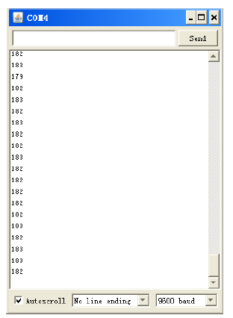

We can see the device is working properly.

Hope my instructions above can help you with your learning. If you have any further questions, feel free to contact us. Thank you!